**Software Requirements Specification**

**for**

**NITKART-Buy and Sell at NITK**

**Version 1.0 approved**

**National Institute Of Technology Karnataka, Surathkal**

**January 17, 2018**

**Table of Contents**

**Table of Contents ii**

**Revision History ii**

**1. Introduction 1**

1.1 Purpose 1

1.2 Document Conventions 1

1.3 Intended Audience and Reading Suggestions 2

1.4 Product Scope 2

1.5 References 2

**2. Overall Description 3**

2.1 Product Perspective 3

2.2 Product Functions 3

2.3 User Classes and Characteristics 3

2.4 Operating Environment 4

2.5 Design and Implementation Constraints 4

2.6 User Documentation 4

2.7 Assumptions and Dependencies 4

**3. External Interface Requirements 5**

3.1 User Interfaces 5

3.2 Hardware Interfaces 6

3.3 Software Interfaces 6

3.4 Communications Interfaces 6

3.5 IDE Interfaces 7

**4. System Features 8**

4.1 User-Related Information 8

4.2 Buying of products at NITKART 8

4.3 Buying of products at NITKART 9

4.4 Other Features 13

**5. Other Nonfunctional Requirements 14**

5.1 Performance Requirements 14

5.2 Safety Requirements 14

5.3 Security Requirements 14

5.4 Software Quality Attributes 14

5.5 Business Rules 15

**6. Other Requirements 15**

**Appendix A: Glossary 15**

**Appendix B: Analysis Models 16**

**Appendix C: To Be Determined List 16**

**Project Budget Estimation 16**

**Revision History**

|  |  |  |  |
| --- | --- | --- | --- |
| **Name** | **Date** | **Reason For Changes** | **Version** |
| - | - | - | - |

**1. Introduction**

**1.1 Purpose**

The SRS will provide a detailed description of the requirements for NITKART-Buy and Sell App at NITK. This SRS can leave a whole understanding of what's to be expected from the recently introduced system that is to be made. The clear understanding of the system and its functionality will allow for the correct software to be developed for the end user and will be used for the development of the further stages of the project.

**1.2 Document Conventions**

The document is prepared using Google Docs and has used the font type ‘Times New Roman’. The font size that has been used to type this document is 14pt for the headings and 11pt for the corresponding body. Standard IEEE template is the template used to recognize the appearance of the document and its flow.

**1.3 Intended Audience and Reading Suggestions**

This document is made by keeping in mind different types of readers. This document will be useful for different audience in various ways.

|  |  |
| --- | --- |
| **Audience** | **Use** |
| Developers | They will use this document as a guidance for design and implementation phase. |
| Managers | They will see all the constraints are covered properly. Time and cost is within limits or not. |
| Marketing Staff | They can use this document to make advertisements for this android app because by reading this document they will know what the system will do? How this system is different from others. |
| User | By reading the SRS they can ensure whether their needs are being met by the App or not. |
| Testers | They will test the implementation of the project according to the SRS base. |
| Documentation Writer | They will use this document during the documentation of the project. |

**1.4 Product Scope**

The System developed will enable the users(residents of NITK) to buy and sell commodities in NITK Surathkal. It may be Electronic items, Household items, Books, Cycle, etc. Since everyone is leading a busy life, time means a lot to everyone. It requires lot of time to travel to a particular shop to buy the goods or sell their products.

**1.5 References**

* IEEE. IEEE Std. 830-1998 IEEE Recommended Practice for Software Requirements Specifications. IEEE Computer Society, 1998.

**2. Overall Description**

**2.1 Product Perspective**

The NITKART - Buy and Sell at NITK project is a new, self-contained product intended for use on the Android platform. NITKART App enables us to access information related to the products posted by the users. Exchange of commodities in NITK can be eased in a systematic way through the App. Users can buy and sell goods or products online just by visiting the app. The seller needs to post the publicity by attaching description of the product(including the pics) and his/her details. The buyer will get the contact details(of the seller) if he/she is inquisitive about shopping for the merchandise. Hence each the parties have to be compelled to reciprocally believe the value of the merchandise and therefore the time of the meeting (either to look at or get the product).

**2.2 Product Functions**

* Serves static data related to the user profile.
* Serves up to date dynamic data related to the products.

**2.3 User Classes and Characteristics**

|  |  |
| --- | --- |
| **User** | **Characteristics** |
| System Admin | It will be the system administrator. He will maintain the overall App. |
| Buyers | It includes the users who seek for products. |
| Sellers | It includes the users who sell the products. |

**2.4 Operating Environment**

NITKART is a software application, which will be limited to the Google’s Android Mobile operating System. The application is not resource- or graphics-intensive, so there are no practical hardware constraints. The app will rely on several functionalities built into Google’s API, so ensuring appropriate usage of the API will be a major concern.

**2.5 Design and Implementation Constraints**

The primary design constraint is the mobile platform. Since the application is designated for mobile handsets, limited screen size and resolution will be a major design consideration. Creating a user interface which is both effective and easily navigable will pose a difficult challenge. Other constraints such as limited memory and processing power are also worth considering.

**2.6 User Documentation**

* A brochure will be provided describing the functionality of the App.

**2.7 Assumptions and Dependencies**

* The Admin will provide the APIs to get information about buying and selling of products at NITK.
* The project requires a host and server, google play store developer account to publish the app.
* The server should support given software dependencies.

**3. External Interface Requirements**

**3.1 User Interfaces**

* The Mobile Application will have a intuitive and clean home interface following Google’s Material Design.
* Mobile App will also have different fragments for Buy, Sell and User profile. We propose for the app to have minimal yet sleek UI with home page highlighting important information about the products.
* Below are some representational pictures for the Mobile App UI……(to be added at the end of the project)

**3.2 Hardware Interfaces**

* The Android Application will be compatible with devices having version 6.0 Marshmallow or later.
* Wearable devices will not be supported with this application.

**3.3 Software Interfaces**

* We propose to use of Django Rest-API for fetching the product and user information.
* For designing Android App we will be using Java as our preferred language for development.
* Most of the softwares used will be Open Source.

**3.4 Communications Interfaces**

The Communication Network must have:

* Fast and reliable network medium.
* Secure protocols.

**3.5 IDE Interfaces**

* JetBrains Android Studio for Android Dev and JetBrains PyCharm for Django.

**4. System Features**

**4.1 User-related Information**

|  |  |
| --- | --- |
| **Use Case Name** | User-Related Information |
| **Actor** | User |
| **Overview** | This use case is about user information. |
| **Pre-condition** | The internet connection is working. Server is not down. |
| **Post-condition** | Information about the user who will use the app.. |

**Typical Course Of Events**

|  |  |
| --- | --- |
| **Actor Action** | **System Response** |
| User request for user detail | App will generate the page. |
| User will fill the required fields | App will post the information. |

**4.2 Buying of products at NITKART**

|  |  |
| --- | --- |
| **Use Case Name** | Buying of products |
| **Actor** | User |
| **Overview** | This use case is buying at NITK |
| **Pre-condition** | The internet connection is working. Server is not down. |
| **Post-condition** | Details about the product should be displayed. |

**Typical Course Of Events**

|  |  |
| --- | --- |
| **Actor Action** | **System Response** |
| User views the product and the relevant information. | App will generate the page. |

**4.3 Selling of products at NITKART**

|  |  |
| --- | --- |
| **Use Case Name** | Selling of products at NITKART |
| **Actor** | Seller |
| **Overview** | This use case is about statutory rules and regulations for passengers. |
| **Pre-condition** | The internet connection is working. Server is not down. |
| **Post-condition** | Details about statutory rules and regulations for passengers in Airport should be displayed. |

**Typical Course Of Events**

|  |  |
| --- | --- |
| **Actor Action** | **System Response** |
| User posts the product and the relevant information. | App will generate the page |

**4.4 Other Features**

Following are the features to be considered irrespective of the above given System Features.

|  |  |
| --- | --- |
| **Features** | **Android App** |
| **Scalability of the Application** | Medium |
| **Level of UI** | Polished |
| **Users & Accounts** | NIL |
| **Dates & Locations:**   * **Calendaring** * **Display of custom maps** |  |
| **Admin, Feedback & Analytics**   * **User Admin Pages** * **Usage Analytics** * **Crash Reporting** * **Performance Monitoring** |  |
| **External APIs and Integrations**   * **Connect to one or more third party services** |  |

**5. Other Nonfunctional Requirements**

**5.1 Performance Requirements**

* Data in the database should be updated within 2 seconds.
* Query results must return within 5 seconds.

**5.2 Safety Requirements**

* Under failure, system should be able to come back at normal operation in one or two hours.

**5.3 Security Requirements**

* All external communications between the data’s server and client must be encrypted.
* All data must be stored and protected.

**5.4 Software Quality Attributes**

* The App is easy to use.
* All the features present in the App are easy to locate.
* The App uses simple English so that the user does not get confused with the terms.

**5.5 Business Rules**

* System Admin - It will be the system administrator. He will maintain the overall Database.
* Users - It includes the people who will view buy and sell products.

**6. Other Requirements**

Currently there are no other known requirements for the project. However this may change in the event of unforeseen circumstances encountered during the duration of the project.

**Appendix A: Glossary**

|  |  |
| --- | --- |
| **Term** | **Description** |
| SRS | Software Requirements Specification |
| IEEE | Institute of Electrical and Electronics Engineers |
| User/Customer | Person using the App. |
| API | Application Program Interface |
| GUI | Graphical User Interface |
| IDE | Integrated Development Environment |

**Appendix B: Analysis Models**

***Use Case Model:*** UML is a way of visualizing a software program using a collection of diagrams. UML stands for Unified Modeling Language. Today, UML is accepted by the Object Management Group (OMG) as the standard for modeling software development. For our software the UML diagram is discussed in details in this section.

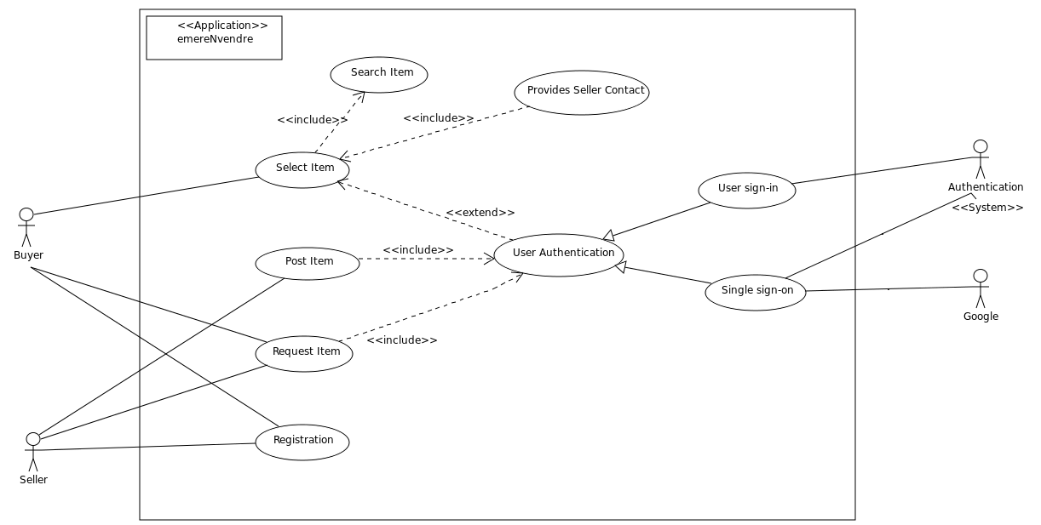

***List of Use cases***

Use cases allow to capture requirements of systems under design or consideration, describe functionality provided by those systems, and determine the requirements the systems pose on their environment.

|  |  |  |  |  |
| --- | --- | --- | --- | --- |
| **S.No** | **Use case**  **Name** | **Description** | **Pre condition** | **Post condition** |
| 01 | Select Item | Buyer selects item which it wants from the item present in the database. | The Item has to be searched for it to be selected. | The desired item has been selected. |
| 02 | Provides Seller Contact | Buyer gets the contact details of the seller for negotiation. | The Item has to be selected by the buyer. | The buyer gets the seller’s contact details for negotiation. |
| 03 | Post Item | Seller posts the information of the item to be sold. | The Seller has to do User Authentication. | The Seller successfully provides the details of the item. |
| 04 | Request Item | Buyer provide detail of the item which is it wants. | The Buyer has to do User Authentication. | The Buyer successfully puts the request of the item it wants. |
| 05 | Registration | Buyer or Seller register in the web application for sign-in. | User has to fill required form for the Registration. | User has been successfully  registered. |
| 06 | User Authentication | The process of confirming the identity of the User ( Buyer or Seller). | User has to be registered in the application or have a google account. | The Identity of the User is confirmed. |
| 07 | User sign-in | The process of confirming the identity of the User through the data present in the database of the application. | User has to be registered in the application. | The Identity of the User is confirmed. |
| 08 | Single sign-on | The User can login to the System through google account. | The User should have a google account. | The Identity of the User is confirmed. |

***List of Actors***

An actor is [behaviored classifier](https://www.uml-diagrams.org/common-behaviors.html#behaviored-classifier) which specifies a role played by an external entity that interacts with the [subject](https://www.uml-diagrams.org/use-case-subject.html) (e.g., by exchanging signals and data), a human user of the designed system, some other system or hardware using services of the subject.

|  |  |  |
| --- | --- | --- |
| **S.No** | **Actor Name** | **Description/ Actor’s Role** |
| 01 | Buyer | The User who uses the application to search a particular item which they want to purchase.It can even put a request for an item which it want. |
| 02 | Seller | The User who uses the application for the purpose to sell a particular item. It post details of the item it want to sell.It can even view the request of an item made by someone. |
| 03 | Authentication | The authentication process through which a user can gain recognition by the application. |
| 04 | Google | Gmail Id can be used for the authentication process to gain recognition by the application. |

**Appendix C: To Be Determined List**

* Not yet done as the application is still in requirement phase.

**Project Budget Estimation**

|  |  |
| --- | --- |
| **Number of Team Members** | 2 |
| **Price (per hour)** | NA |
| **Number of working hours per day** | 2 hrs |
| **Total price (per day)** | NA |
| **Number of working days per week** | 5 days |
| **Estimated number of months to complete the project** | 3 months |
| **Total Price** | NIL |